







Software Requirements Specification

ReadySetResource.com

Contents

4.1 - Purpose 5

4.2 - Critical Requirements 5

4.3 - Functional and Non-Functional Requirements 5

Non-Functional Requirements 6

4.4 - User Requirements 6

4.5 - Assumptions 7

4.6 - Constraints 7

Monetary Constrains 7

Time Constrains 7

Resource Constrains 7

4.7 - Dependencies 7

4.8 - High Level System Logic 8

/home/ 8

/get/ 9

/legal/ 9

/contact/ 9

/help/ 10

/admin/ 10

/dev/ 11

/analytics/ 11

/head/ 11

/dashboard/ 12

4.9 – Detailed Requirements 13

Requirement 1 13

Requirement 2 13

Requirement 2 13

Requirement 2 13

Requirement 2 13

Requirement 2 14

Requirement 2 14

Requirement 2 14

Requirement 2 14

Requirement 2 14

Requirement 2 15

Requirement 2 15

Requirement 2 15

Requirement 2 15

Requirement 2 15

Requirement 2 16

Requirement 2 16

Requirement 2 16

Requirement 2 16

Requirement 2 16

Requirement 2 17

Requirement 2 17

Requirement 2 17

Requirement 2 17

Requirement 2 17

Requirement 2 18

Requirement 2 18

Requirement 2 18

Requirement 2 18

Requirement 2 18

Requirement 2 19

Requirement 2 19

Requirement 2 19

Requirement 2 19

Requirement 2 19

Requirement 2 20

Requirement 2 20

Requirement 2 20

Requirement 2 20

Requirement 2 20

Requirement 2 21

Requirement 2 21

Requirement 2 21

Requirement 2 21

Requirement 2 21

Requirement 2 22

Requirement 2 22

Requirement 2 22

Requirement 2 22

Requirement 2 22

Requirement 2 23

4.10 - Bibliography 24

4.11 - Software Requirements Spec. Work Log 24

# 4.1 - Purpose

The purpose of this project is to be able to aid in the productivity of backend logistics within the public sector. Maximizing effectiveness and efficiency is key in aiding productivity and being able to provide all details necessary for employees to be able to work easier with less distractions would benefit members of staff and thus will strive for these targets in this project.

# 4.2 - Critical Requirements

The system that will be built must be able to:

* + - Display the website to provide information on the web apps
    - Allow the user of the system to contact a member of staff in a contact form
    - Sign a company or a business up to the service
    - Charge a customer on a monthly/yearly basis
    - Allow the ‘administrator’ of a company to:
      * + Add, delete and modify users’ details
        + Create rotas
        + Message members of staff
    - Allow employees of a company to:
      * + View their rotas
        + Message other members of staff
    - Allow experts to:
      * + Add, delete and modify users’ details
        + Add, delete and modify companies’ details
        + Query a database of questions
        + Respond to questions
        + Close questions
    - Allow developers to:
      * + Shut down and start up the system

# 4.3 - Functional and Non-Functional Requirements

Functional requirements, put simply, are what the system that is being built must do. Non-functional requirements are interested in defining other constraints and achievements. To see a list of the functional requirements please go to 2.13 - General System Requirements in the 2 - Planning Report.

Non-Functional Requirements

Performance: The website needs to run smoothly and reliably. To achieve this, we need to look at the capacity of the server and to not DOS it by accident by controlling RAM usage per user and number of users.

Capacity: Through multiple tests that have been conducted, the average usage of RAM per user is around 80MB. Assuming that it is both the same for the client as the server (although it probably will differ) the hosting plan that will be purchased will be 2GB of RAM and therefore at any one time the system can have 25 users. More tests will need to be done so that we can ensure that those figures are correct, but once the project starts to grow we are able to upgrade the hosting plan and even move it to our own servers.

Availability: The website will be available world-wide but you may only register if you are a company in the UK. This is due to legalities and due to the server being hosted in the UK which means speeds will be reduced to other countries.

Fault Tolerance: Maintaining high cohesion and low coupling will ensure that fault tolerance is minimum. After release, more tests will be carried out to ensure that fault tolerance is dealt with as much as possible.

Quality of Service: The quality that is produced needs to be as high as possible as this will entice users to use the system more and recommend to others.

Portability: We are going to ensure that the website can be viewed dynamically on computers, laptops, tablets and phones. Due to the increase usage of mobile devices, a large portion of users would be excluded if the website was not portable.

# 4.4 - User Requirements

In this system, all the general requirements are also user requirements. To see a list of the functional requirements please go to 2.13 - General System Requirements in the 2 - Planning Report.

# 4.5 - Assumptions

There are many assumptions to make about this project. The main ones being:

* + - I can meet the deadline and complete every aspect of the project
    - That users can navigate and use the computer and internet with ease
    - That users can speak English
    - That the website will be able to be hosted and published to a hosting environment
    - The file hosting platform will be safe, secure and reliable
    - The developer(s) can write the software required of them

# 4.6 - Constraints

Monetary Constrains

Due to the nature of this project, the monetary constraints for this project will be outlined in the Business Plan. This will provide an in-depth look at estimated costs, profits, break even analysis and more.

Time Constrains

City of Glasgow College has put upon the project many deadlines for different aspects of the project. To view a full list of deadlines please view 3 - Student’s Agreement.

Resource Constrains

Due to the monetary constrains, we are not able to purchase hardware and therefore must use hosting environments which will reduce the short-term costs but increase the long-term cost and will also limit the main memory and processing power. In addition, there are currently a shortage of workers dedicated to this project and will require an increase of man power if we wish the project to stay afloat.

# 4.7 - Dependencies

The main dependencies of the project are:

* + - Acceptance from the lecturers required to be able to develop this project
    - The Integrated Development Environment will allow us to publish the project for free
    - The web host will be cheap, easy to use and consistently reliable
    - A good knowledge of the Software Development Life Cycle from all parties

# 4.8 - High Level System Logic

There will be a total of 10 sections of the website that co-exist in the same domain name all under different subdomains. The following are high level overviews of the system. To see the main system interface, please see documents 7 through 16. Documents 7 through to 16 also contain the input permissible and error messages per screen. The sections of websites are diagrammed as followed to show the high-level map of the system being constructed:

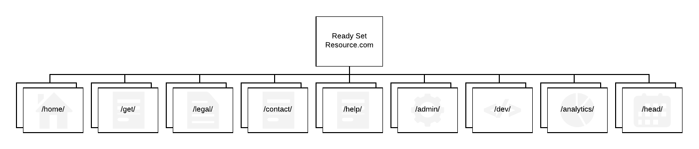

/home/

This section will contain all the information over our services. When a potential customer searches for this system, they will be directed to this website. On the website they will receive information over how the system works, and links to other websites in the same system to be able to complete their requested action (for example logging on or signing 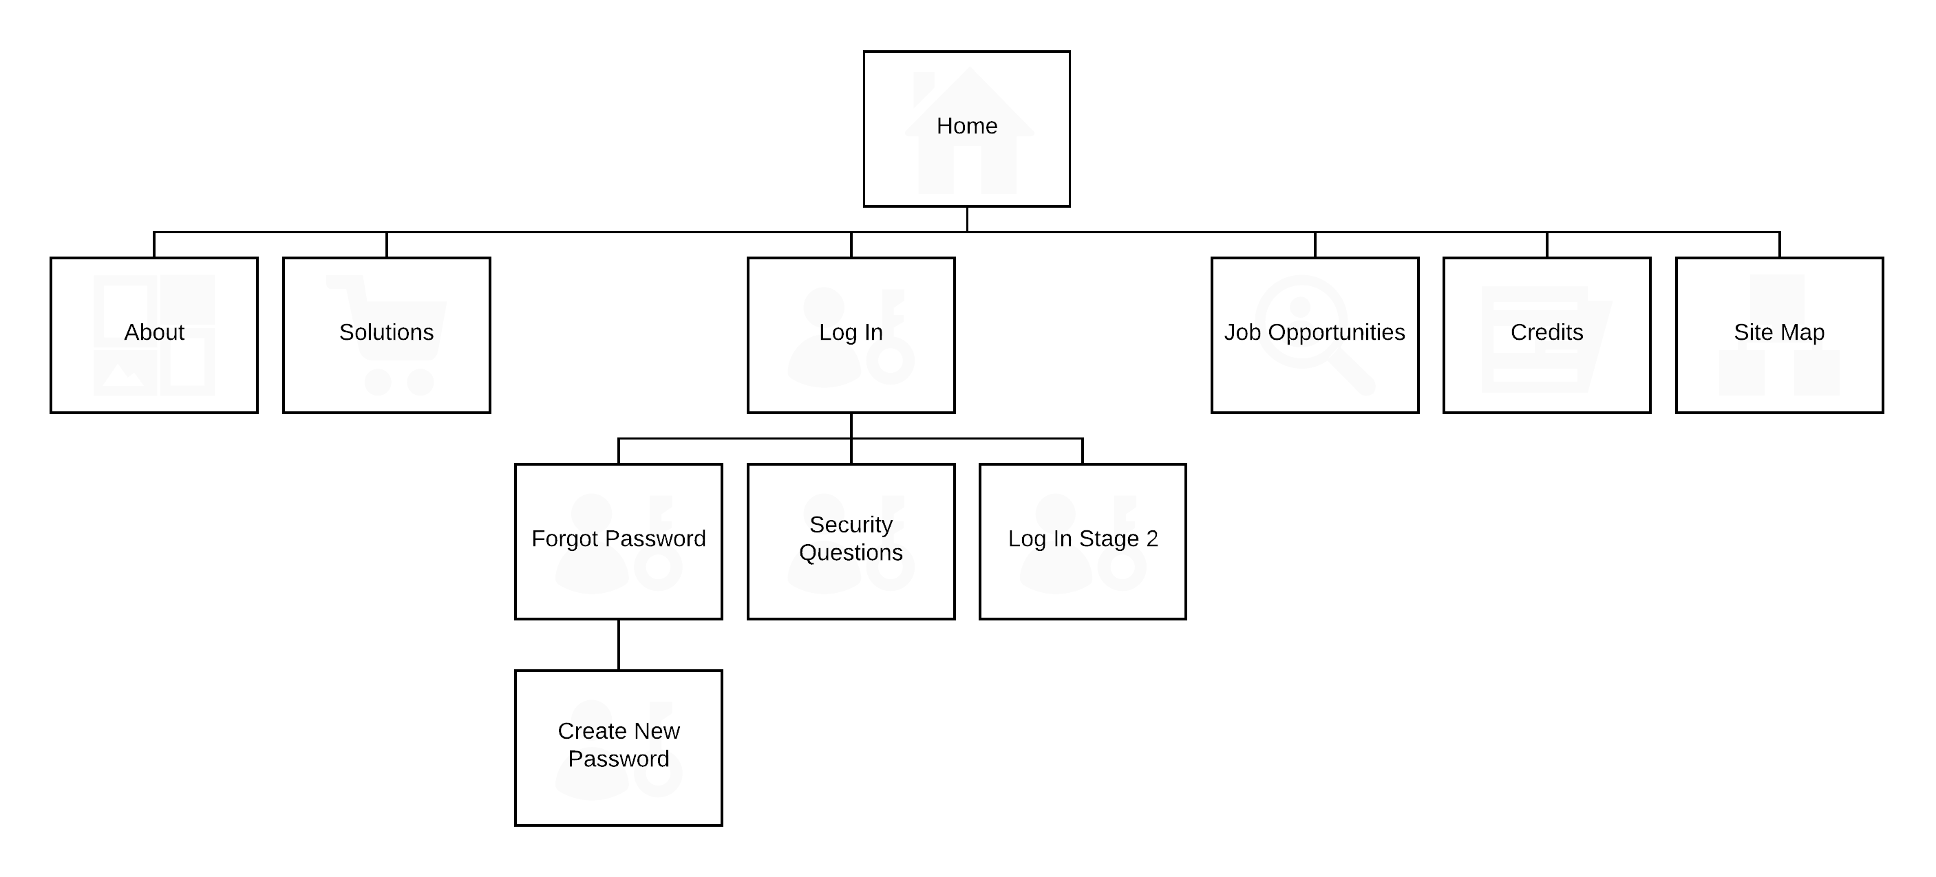up). This will be a hierarchical website.

/get/

This section will simply contain the system’s registration process. An easy 3 step process that takes customer information and creates an instance in the system and adds it into the database. This will be a linear website.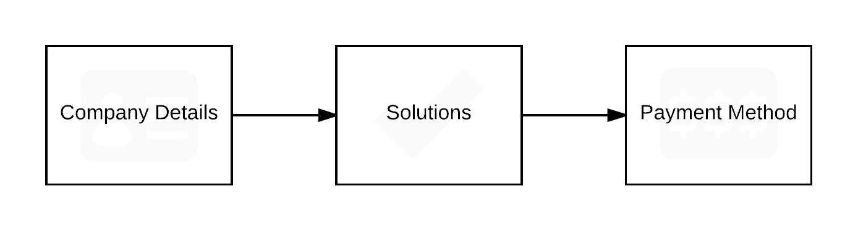

/legal/

This section will contain the system’s legal concerns. Another small website that is concerned with providing the system’s visitors and customers our terms and conditions, copyright policy and privacy policy. This will be a hierarchical website.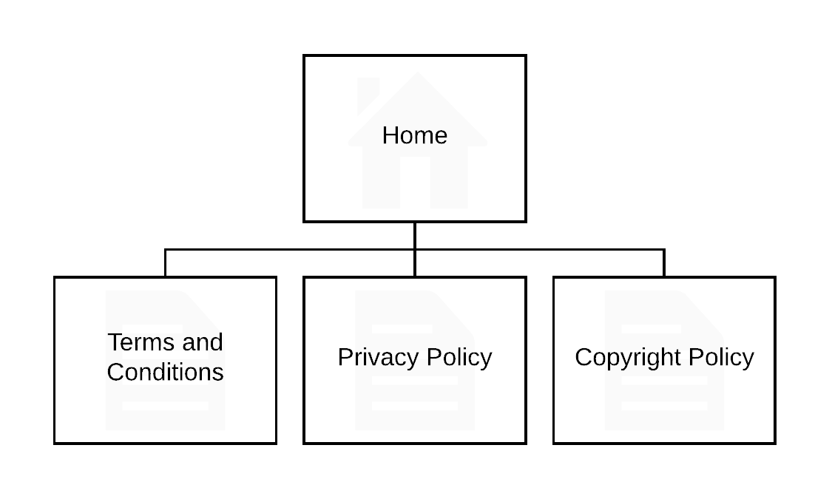

/contact/

This section will be concerned with allowing the customer to contact us regarding issues they are having with the system. This website allows the customer to fill out a form and it will be saved to the database allowing an employee to reply. This will be a linear website.

/help/

This section will produce a platform for users to be able to ask questions and answer questions. It will create a community of workers that will be able to discuss topics and help each other out. This will be a hierarchical website.

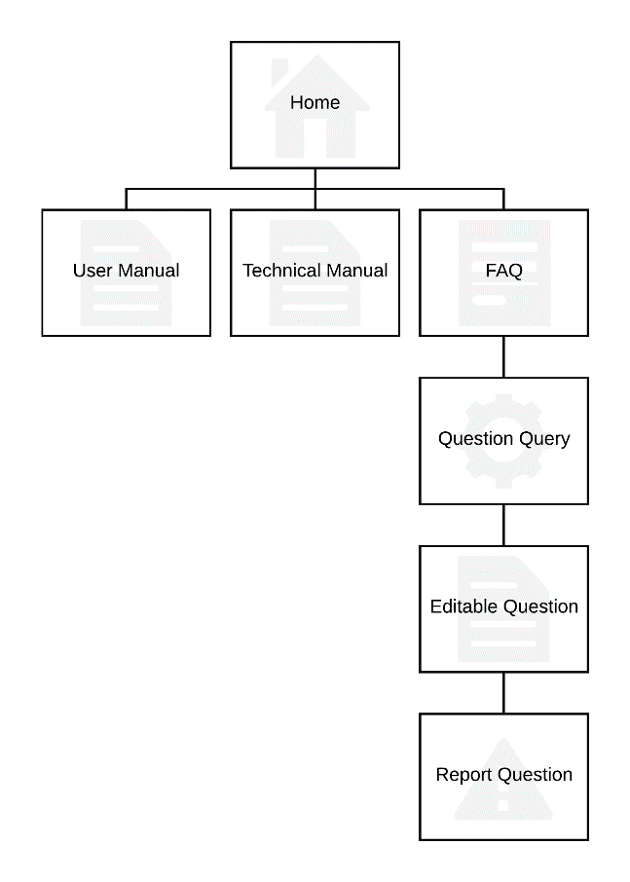

/admin/

This section will be for employees of the system. It will form a platform so that ‘experts’ can answer questions that users have asked via the ‘contact.’ website. This will be a hierarchical website.

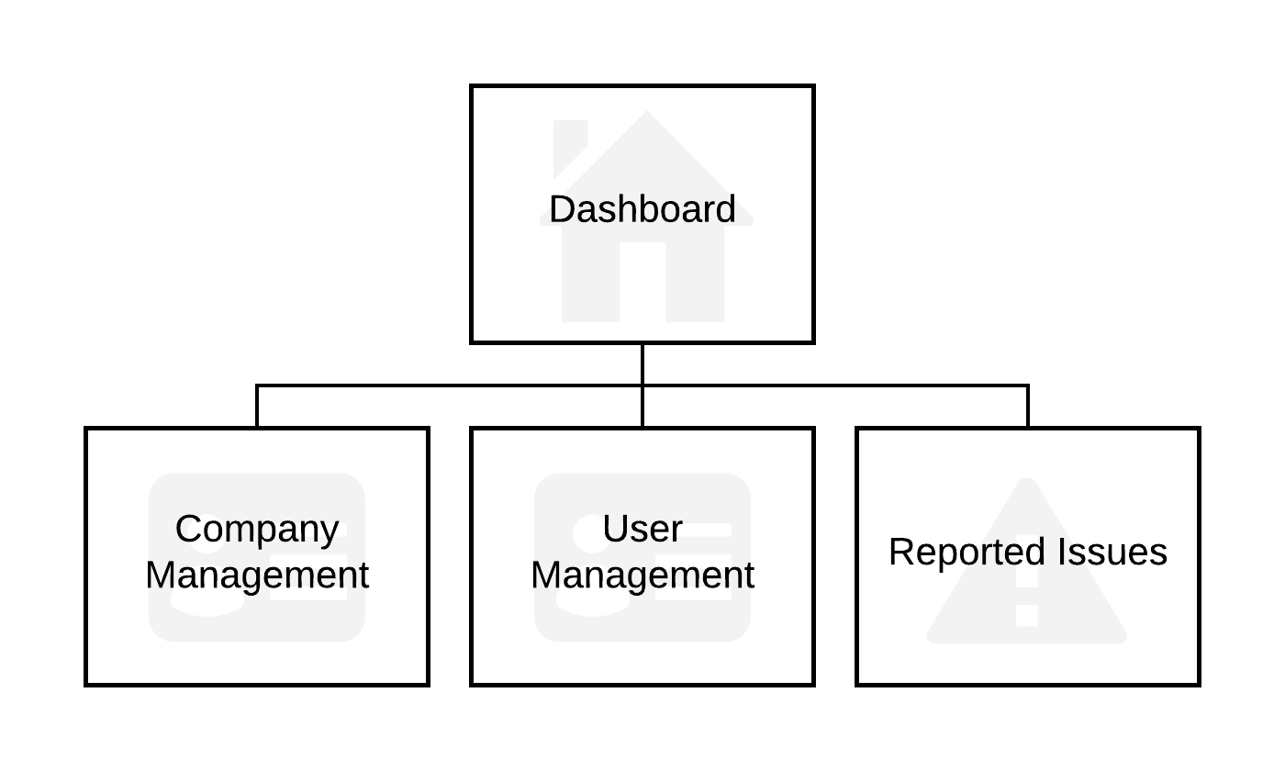

/dev/

This section will be for employees of the system. It will form a platform so that ‘developers’ of the system can run reports to see how the system is coping, any errors the system has encountered and the ability to start up and shut down the system. This will be a hierarchical website.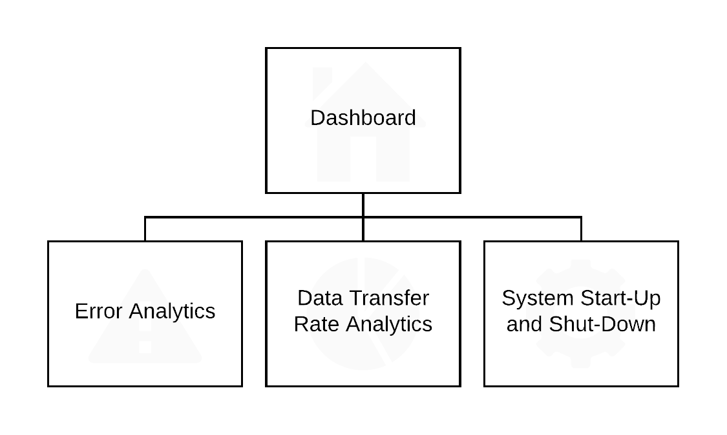

/analytics/

This section will be for employees of the system. It will form a platform so that ‘systems analysts’ can run reports to analyse trends of usage and management of storage space. This will be a hierarchical website.

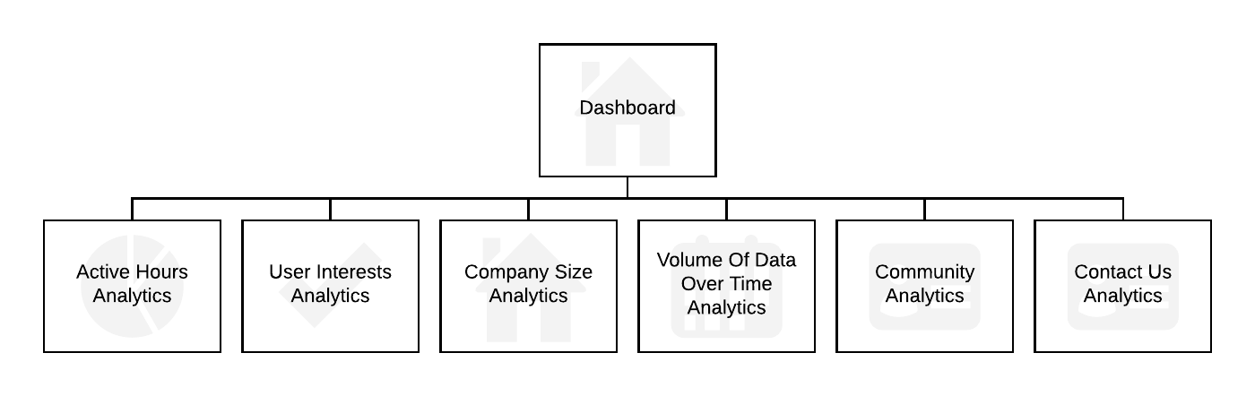

/head/

This section will be for employees of the system. It will form a platform so that the ‘COO’ manage their employees and see how the company is doing. This will be a hierarchical website.

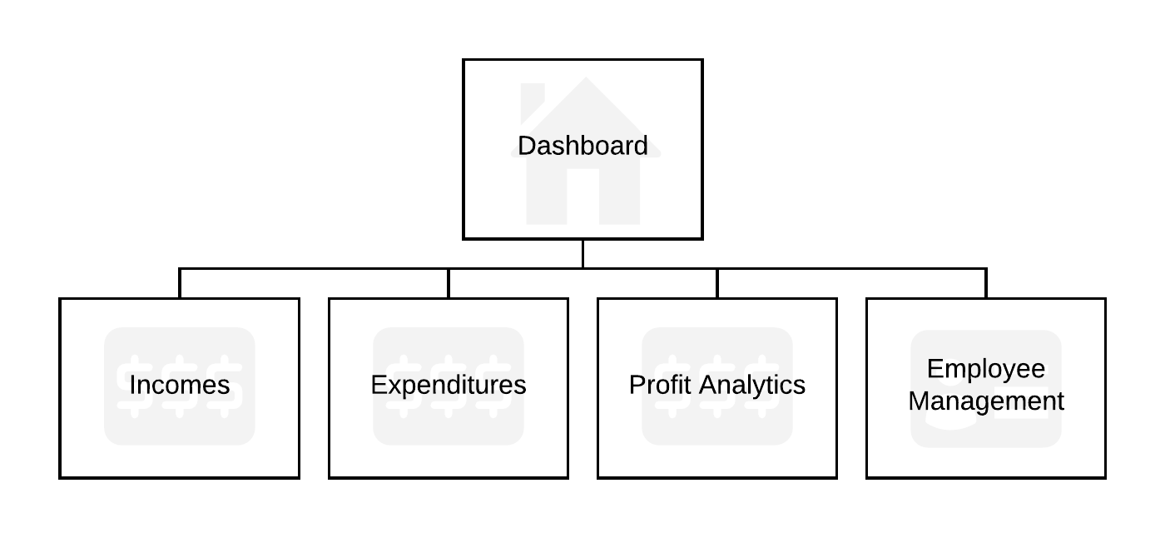

/dashboard/

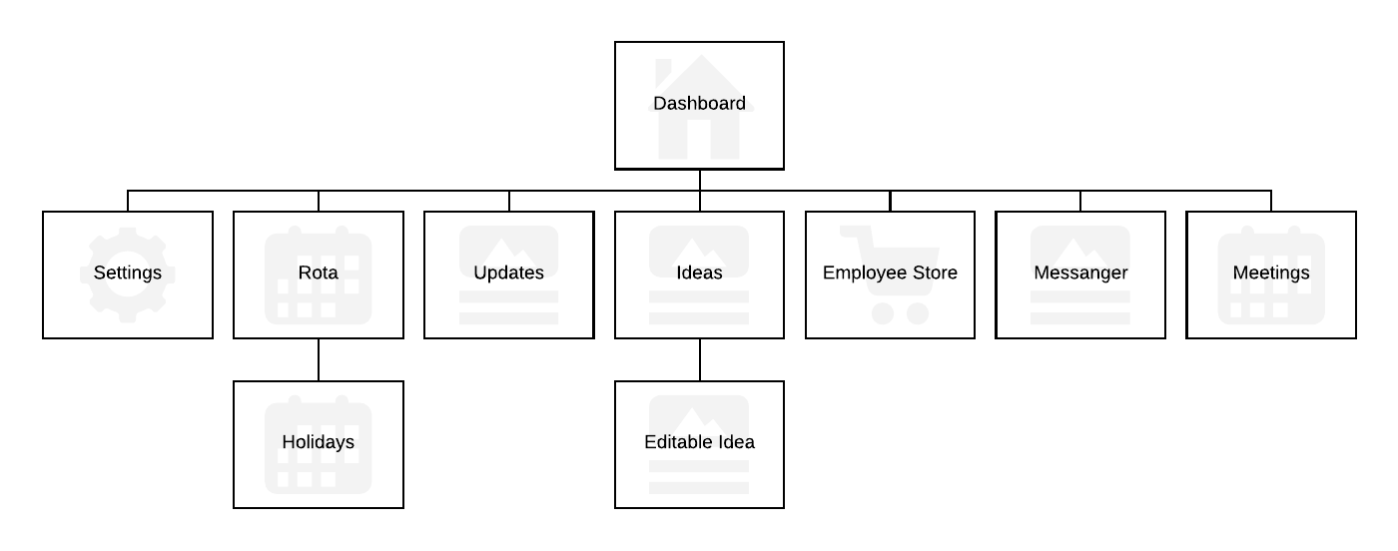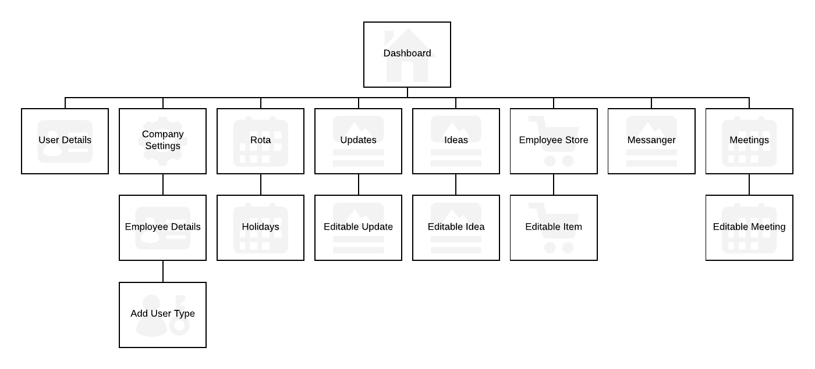This section will be for customers of the system. It is the reason the system was developed. It provides 6 applications: Rota, Updates, Ideas, Employee Store, Messenger and Meetings. This will be a hierarchical website for both customers that are administrators and employees.

# 4.9 – Detailed Requirements

Requirement 1

|  |  |
| --- | --- |
| Brief Description (Purpose): | Display the website to provide information on the web app |
| Minimum Input Required: | The user attempts to access the server |
| Minimum Processing Required: | The home page should load to the user’s browser |
| Minimum Output Required: | The home page appears |

Requirement 2

|  |  |
| --- | --- |
| Brief Description (Purpose): | Allow the user of the system to contact a member of staff in a contact form |
| Minimum Input Required: | The user fills out a form with the following information: name, email, issue type and description |
| Minimum Processing Required: | The details get sent to the database and saved |
| Minimum Output Required: | The user gets re-directed to a thank you page. |

Requirement 3

|  |  |
| --- | --- |
| Brief Description (Purpose): | Allow a form or ‘community’ to be created to connect users with the same issues |
| Minimum Input Required: | The user searches for an issue |
| Minimum Processing Required: | The website pulls issues from the database which relate to the search query |
| Minimum Output Required: | A list of issues is displayed |

Requirement 4

|  |  |
| --- | --- |
| Brief Description (Purpose): | Display a clear and informative FAQ section |
| Minimum Input Required: | The user directs themselves to the page where the FAQ is on |
| Minimum Processing Required: | A list of frequently asked questions is pulled from the database |
| Minimum Output Required: | The FAQ page appears with a list of frequently asked questions |

Requirement 5

|  |  |
| --- | --- |
| Brief Description (Purpose): | Sign a company or a business up to the service easily |
| Minimum Input Required: | The details of the business and the first administrator along with payment details. |
| Minimum Processing Required: | The details are saved into the database and the card/PayPal account is charged. |
| Minimum Output Required: | The home screen in the /dashboard/ section opens with a greeting. |

Requirement 6

|  |  |
| --- | --- |
| Brief Description (Purpose): | Allow users to report abusive behaviour |
| Minimum Input Required: | A mouse click on the report button |
| Minimum Processing Required: | An entry is saved to the database |
| Minimum Output Required: | A popup appears saying that the report was successful |

Requirement 7

|  |  |
| --- | --- |
| Brief Description (Purpose): | Allow for future discount codes |
| Minimum Input Required: | An ‘invisible’ text box that will later become active |
| Minimum Processing Required: | None currently |
| Minimum Output Required: | None currently |

Requirement 8

|  |  |
| --- | --- |
| Brief Description (Purpose): | Allow users to view any relevant legalities and information |
| Minimum Input Required: | The user directs themselves to the /legal/ section of the website |
| Minimum Processing Required: | The legal web-pages are sent to the client’s browser |
| Minimum Output Required: | The pages are rendered |

Requirement 9

|  |  |
| --- | --- |
| Brief Description (Purpose): | Allow users to view all credits and sources |
| Minimum Input Required: | The user directs themselves to the credits page of the website |
| Minimum Processing Required: | The legal web-pages are sent to the client’s browser |
| Minimum Output Required: | The page is rendered |

Requirement 10

|  |  |
| --- | --- |
| Brief Description (Purpose): | Charge a customer on a monthly/yearly basis |
| Minimum Input Required: | The customer’s payment details |
| Minimum Processing Required: | The date is checked every day to the last billed date of the customer |
| Minimum Output Required: | The customer is billed |

Requirement 11.1

|  |  |
| --- | --- |
| Brief Description (Purpose): | Allow the ‘administrator’ of a company to make basic administrative tasks |
| Minimum Input Required: | Company details |
| Minimum Processing Required: | The details are saved to the database |
| Minimum Output Required: | The details are shown on the company settings page |

Requirement 11.2

|  |  |
| --- | --- |
| Brief Description (Purpose): | Allow the ‘administrator’ of a company to add, delete and modify users’ details |
| Minimum Input Required: | A user’s details |
| Minimum Processing Required: | The details are saved to the database |
| Minimum Output Required: | The details are shown on the company settings page |

Requirement 11.3

|  |  |
| --- | --- |
| Brief Description (Purpose): | Allow the ‘administrator’ of a company to view requested holidays |
| Minimum Input Required: | The user directs themselves to the requested holidays page of the website |
| Minimum Processing Required: | A view with a list of holidays is sent to the client’s browser |
| Minimum Output Required: | The view is rendered |

Requirement 11.4

|  |  |
| --- | --- |
| Brief Description (Purpose): | Allow the ‘administrator’ of a company to set a limit on number of holidays a year |
| Minimum Input Required: | The user accepts or declines requested holidays |
| Minimum Processing Required: | The details are updated to the database |
| Minimum Output Required: | If the user rejects the request, the status is updated. |

Requirement 11.5

|  |  |
| --- | --- |
| Brief Description (Purpose): | Allow the ‘administrator’ of a company to set holidays |
| Minimum Input Required: | Start date, time and end date, time |
| Minimum Processing Required: | The details are updated to the database |
| Minimum Output Required: | The view is reloaded with the added holiday |

Requirement 11.6

|  |  |
| --- | --- |
| Brief Description (Purpose): | Allow the ‘administrator’ of a company to form analytical reports on their employees |
| Minimum Input Required: | Select week from calendar |
| Minimum Processing Required: | The details are updated to the database |
| Minimum Output Required: | The table is shown with the data inputted |

Requirement 11.7

|  |  |
| --- | --- |
| Brief Description (Purpose): | Allow the ‘administrator’ of a company to create rotas with ease |
| Minimum Input Required: | List of times at dates for each person |
| Minimum Processing Required: | The details are updated to the database |
| Minimum Output Required: | The table is shown with the data inputted |

Requirement 11.8

|  |  |
| --- | --- |
| Brief Description (Purpose): | Allow the ‘administrator’ of a company to message members of staff |
| Minimum Input Required: | The user creates a message in the text box and clicks send |
| Minimum Processing Required: | The details are updated to the database |
| Minimum Output Required: | The messenger view which has a new box with the submitted message. |

Requirement 11.9

|  |  |
| --- | --- |
| Brief Description (Purpose): | Allow the ‘administrator’ of a company to create updates for employees and/or stores |
| Minimum Input Required: | The user creates a user and title in the text box and clicks create |
| Minimum Processing Required: | The details are updated to the database |
| Minimum Output Required: | The updates view which has a new box with the submitted update |

Requirement 11.10

|  |  |
| --- | --- |
| Brief Description (Purpose): | Allow the ‘administrator’ of a company to create sales drives for employees and/or stores |
| Minimum Input Required: | The user creates a message in the text box and clicks create |
| Minimum Processing Required: | The details are updated to the database |
| Minimum Output Required: | The sales drives view which has a new box with the submitted message |

Requirement 11.11

|  |  |
| --- | --- |
| Brief Description (Purpose): | Allow the ‘administrator’ of a company to upload ‘items’ to an online store for employees |
| Minimum Input Required: | The user creates a title, description and image in the text box and clicks create |
| Minimum Processing Required: | The details are updated to the database |
| Minimum Output Required: | The store view which has a new box with the submitted item |

Requirement 11.12

|  |  |
| --- | --- |
| Brief Description (Purpose): | Allow the ‘administrator’ of a company to set the pricing structure for said ‘items’ |
| Minimum Input Required: | In the description box when creating an item, they can fill out a price if desired, but transactions will not be processed on the website. |
| Minimum Processing Required: | The entry is saved onto the database |
| Minimum Output Required: | The user gets re-directed to the main page where they will see their item. |

Requirement 11.13

|  |  |
| --- | --- |
| Brief Description (Purpose): | Allow the ‘administrator’ of a company to create and set meetings |
| Minimum Input Required: | The user creates a title, description and datetime in the text box and clicks create |
| Minimum Processing Required: | The details are updated to the database |
| Minimum Output Required: | The store view which has a new box with the submitted item |

Requirement 11.14

|  |  |
| --- | --- |
| Brief Description (Purpose): | Allow the ‘administrator’ of a company to receive ideas from their employees |
| Minimum Input Required: | The user directs themselves to the requested ideas page of the website |
| Minimum Processing Required: | A view with a list of ideas is sent to the client’s browser |
| Minimum Output Required: | The view is rendered |

Requirement 12.1

|  |  |
| --- | --- |
| Brief Description (Purpose): | Allow employees of a company to view their rotas |
| Minimum Input Required: | The user directs themselves to the requested rota page of the website |
| Minimum Processing Required: | A view with a list of ideas is sent to the client’s browser |
| Minimum Output Required: | The view is rendered |

Requirement 12.2

|  |  |
| --- | --- |
| Brief Description (Purpose): | Allow employees of a company to view their holidays |
| Minimum Input Required: | The user directs themselves to the requested holiday page of the website |
| Minimum Processing Required: | A view with a list of holidays is sent to the client’s browser |
| Minimum Output Required: | The view is rendered |

Requirement 12.3

|  |  |
| --- | --- |
| Brief Description (Purpose): | Allow employees of a company to request a permitted amount of holidays |
| Minimum Input Required: | The user sets a start date and time and an end date and time |
| Minimum Processing Required: | The details are updated to the database |
| Minimum Output Required: | The store view which has a new box with the submitted holiday |

Requirement 12.4

|  |  |
| --- | --- |
| Brief Description (Purpose): | Allow employees of a company to message other members of staff |
| Minimum Input Required: | The user creates a message in the text box and clicks send |
| Minimum Processing Required: | The details are updated to the database |
| Minimum Output Required: | The messenger view which has a new box with the submitted message |

Requirement 12.5

|  |  |
| --- | --- |
| Brief Description (Purpose): | Allow employees of a company to order ‘items’ on the online store |
| Minimum Input Required: | The user sets a quantity and clicks request |
| Minimum Processing Required: | The details are updated to the database |
| Minimum Output Required: | The store view |

Requirement 12.6

|  |  |
| --- | --- |
| Brief Description (Purpose): | Allow employees of a company to share ideas |
| Minimum Input Required: | The user creates a title and description and clicks submit |
| Minimum Processing Required: | The details are updated to the database |
| Minimum Output Required: | The ideas view |

Requirement 12.7

|  |  |
| --- | --- |
| Brief Description (Purpose): | Allow employees of a company to view updates |
| Minimum Input Required: | The user directs themselves to the updates page of the website |
| Minimum Processing Required: | A view with a list of updates is sent to the client’s browser |
| Minimum Output Required: | The view is rendered |

Requirement 12.8

|  |  |
| --- | --- |
| Brief Description (Purpose): | Allow employees of a company to view meetings |
| Minimum Input Required: | The user directs themselves to the meetings page of the website |
| Minimum Processing Required: | A view with a list of meetings is sent to the client’s browser |
| Minimum Output Required: | The view is rendered |

Requirement 13.1

|  |  |
| --- | --- |
| Brief Description (Purpose): | Allow experts to add, delete and modify users’ details |
| Minimum Input Required: | The user modifies user details and clicks save |
| Minimum Processing Required: | The details are updated to the database |
| Minimum Output Required: | The users view which has an updated field |

Requirement 13.2

|  |  |
| --- | --- |
| Brief Description (Purpose): | Allow experts to add delete and modify companies’ details |
| Minimum Input Required: | The user modifies company details and clicks save |
| Minimum Processing Required: | The details are updated to the database |
| Minimum Output Required: | The companies view which has an updated field |

Requirement 13.3

|  |  |
| --- | --- |
| Brief Description (Purpose): | Allow experts to query a database of questions |
| Minimum Input Required: | A string that will be compared to question titles |
| Minimum Processing Required: | All questions are pulled from the database which have same or similar title |
| Minimum Output Required: | The questions view which has a list of questions |

Requirement 13.4

|  |  |
| --- | --- |
| Brief Description (Purpose): | Allow experts to respond to questions |
| Minimum Input Required: | User details |
| Minimum Processing Required: | The user emails the customer |
| Minimum Output Required: | Questions view is returned |

Requirement 13.5

|  |  |
| --- | --- |
| Brief Description (Purpose): | Allow experts to close questions |
| Minimum Input Required: | The user clicks the close button |
| Minimum Processing Required: | The database is updated |
| Minimum Output Required: | The view is returned with that certain question removed |

Requirement 14.1

|  |  |
| --- | --- |
| Brief Description (Purpose): | Allow developers to analyse errors on the system |
| Minimum Input Required: | The user directs themselves to the errors page of the website |
| Minimum Processing Required: | A view with a list of errors is sent to the client’s browser |
| Minimum Output Required: | The view is rendered |

Requirement 14.2

|  |  |
| --- | --- |
| Brief Description (Purpose): | Allow developers to analyse data transfer rates |
| Minimum Input Required: | The user directs themselves to the data transfer rates page of the website |
| Minimum Processing Required: | A view with a list of data transfer rates is sent to the client’s browser |
| Minimum Output Required: | The view is rendered |

Requirement 14.3

|  |  |
| --- | --- |
| Brief Description (Purpose): | Allow developers to shut down and start up the system |
| Minimum Input Required: | The user directs themselves to the system start up and shut down page of the website |
| Minimum Processing Required: | A view with a list of procedures for shutting the system down or starting it up is sent to the client’s browser |
| Minimum Output Required: | The view is rendered |

Requirement 15.1

|  |  |
| --- | --- |
| Brief Description (Purpose): | Allow systems analysts to create analytical reports on average screen time per day |
| Minimum Input Required: | The user directs themselves to the active hours page of the website |
| Minimum Processing Required: | A view with a list of active hours is sent to the client’s browser |
| Minimum Output Required: | The view is rendered |

Requirement 15.2

|  |  |
| --- | --- |
| Brief Description (Purpose): | Allow systems analysts to create analytical reports on user interests |
| Minimum Input Required: | The user directs themselves to the user interests page of the website |
| Minimum Processing Required: | A view with a list of user interests is sent to the client’s browser |
| Minimum Output Required: | The view is rendered |

Requirement 15.3

|  |  |
| --- | --- |
| Brief Description (Purpose): | Allow systems analysts to create analytical reports on company size |
| Minimum Input Required: | The user directs themselves to the company size page of the website |
| Minimum Processing Required: | A view with a list of company sizes is sent to the client’s browser |
| Minimum Output Required: | The view is rendered |

Requirement 15.4

|  |  |
| --- | --- |
| Brief Description (Purpose): | Allow systems analysts to create analytical reports on volume of data per company over time |
| Minimum Input Required: | The user directs themselves to the data over time page of the website |
| Minimum Processing Required: | A view with a list of data over time is sent to the client’s browser |
| Minimum Output Required: | The view is rendered |

Requirement 15.5

|  |  |
| --- | --- |
| Brief Description (Purpose): | Allow systems analysts to create analytical reports on community answered and unanswered questions. |
| Minimum Input Required: | The user directs themselves to the community page of the website |
| Minimum Processing Required: | A view with a list of community is sent to the client’s browser |
| Minimum Output Required: | The view is rendered |

Requirement 15.6

|  |  |
| --- | --- |
| Brief Description (Purpose): | Allow systems analysts to create analytical reports on Contact Us opened and closed questions. |
| Minimum Input Required: | The user directs themselves to the contact us page of the website |
| Minimum Processing Required: | A view with a list of contact us questions is sent to the client’s browser |
| Minimum Output Required: | The view is rendered |

Requirement 16.1

|  |  |
| --- | --- |
| Brief Description (Purpose): | Allow head of the system to track, modify and add business incomes |
| Minimum Input Required: | The user modifies income details and clicks save |
| Minimum Processing Required: | The details are updated to the database |
| Minimum Output Required: | The incomes view which has an updated field |

Requirement 16.2

|  |  |
| --- | --- |
| Brief Description (Purpose): | Allow head of the system to track, modify and add business expenditures |
| Minimum Input Required: | The user modifies expenditures details and clicks save |
| Minimum Processing Required: | The details are updated to the database |
| Minimum Output Required: | The expenditures view which has an updated field |

Requirement 16.3

|  |  |
| --- | --- |
| Brief Description (Purpose): | Allow head of the system to create an analytical report on incomes and expenditures |
| Minimum Input Required: | The user directs themselves to the transactions page of the website |
| Minimum Processing Required: | A view with a list of transactions is sent to the client’s browser |
| Minimum Output Required: | The view is rendered |

Requirement 16.4

|  |  |
| --- | --- |
| Brief Description (Purpose): | Allow head of the system to add, delete and modify employees’ details |
| Minimum Input Required: | The user modifies user details and clicks save |
| Minimum Processing Required: | The details are updated to the database |
| Minimum Output Required: | The users view which has an updated field |

# 4.10 - Bibliography

City of Glasgow College (2017) Integrative Unit [online]. Available from the World Wide Web: <https://my.cityofglasgowcollege.ac.uk/courses/course/view.php?id=1240> [accessed 21 November, 2017]

# 4.11 - Software Requirements Spec. Work Log

| Entry | Description | Person | Date | Mins Spent |
| --- | --- | --- | --- | --- |
| 1 | Formatted the document | Aidan Marshall | 2/11/17 | 17 |
| 2 | Thought about the purpose of the project | Aidan Marshall | 5/11/17 | 19 |
| 3 | Started the critical requirements | Aidan Marshall | 16/11/17 | 42 |
| 4 | Edited critical requirements | Aidan Marshall | 21/11/17 | 12 |
| 5 | Described the functional requirements | Aidan Marshall | 21/11/17 | 4 |
| 6 | Described the non-functional requirements | Aidan Marshall | 22/11/17 | 46 |
| 7 | Thought about the project’s constraints | Aidan Marshall | 22/11/17 | 26 |
| 8 | Thought about the dependencies of the project | Aidan Marshall | 22/11/17 | 7 |
| 9 | Started figuring out the high system logic | Aidan Marshall | 22/11/17 | 206 |
| 10 | Changed the systems headers | Aidan Marshall | 15/3/18 | 4 |
| 11 | Updated 4.8 to include main system interface | Aidan Marshall | 18/3/18 | 16 |
| 12 | Added the detailed requirements (4.9) | Aidan Marshall | 18/3/18 | 202 |
| 13 | Modified the site maps | Aidan Marshall | 19/3/18 | 41 |
| 14 | Continued the detailed requirements (4.9) | Aidan Marshall | 18/3/18 | 48 |
| 15 | Finished the detailed requirements (4.9) | Aidan Marshall | 19/3/18 | 113 |
| 833 | | | | |